Restaurant Robots: Computerized Chefs
The Age of Robotics is upon us. While this leaves a sour taste in the mouths of many, corporations and roboticists are working as hard as they can to change this. Literally. Several corporations are rolling out restaurant robots, that can both cook food and serve the customer. Despite the mixed feelings that will undoubtedly surround this topic, this change is hopefully a sign of great things to come for automation.
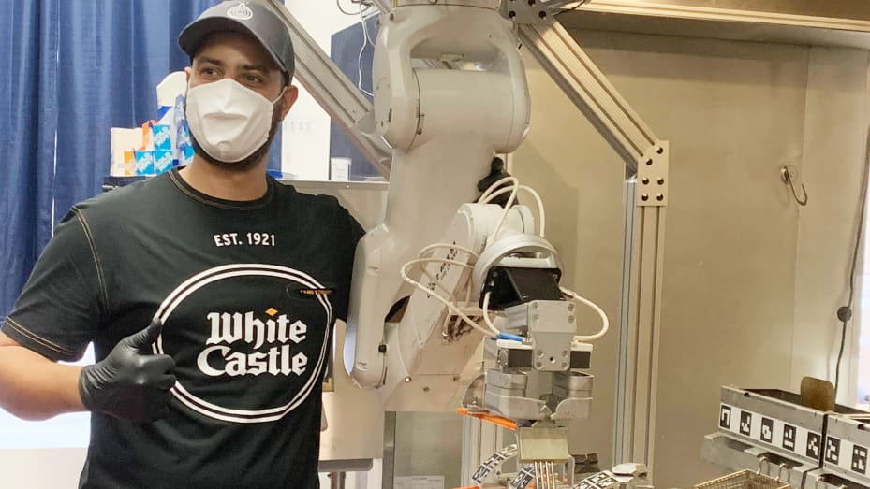
Restaurants looking for labor and speed turn to robots (cnbc.com)
Labor shortages are becoming widespread, particularly for minimum wage jobs. 4 out of 5 restaurants are reported as being understaffed (1). In the wake of this, several companies are looking to automation to resolve their woes. Recently, Miso Robotics introduced a restaurant robot known as “Flippy” (1). It is a high-precision robotic arm, capable of producing and cooking various foods. While it is currently at the high price-point of $20,000 (1), several large chains have already adopted it for testing. Once fully integrated, it will likely be worth the price. It has been reported that the robots allow workers to better interact with customers and provide good customer service.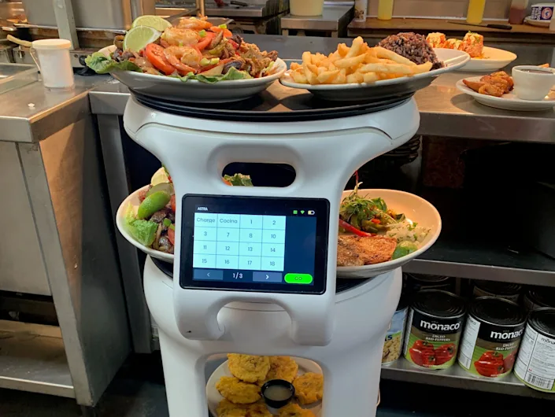
A Florida restaurant chain says staff got bigger tips after it hired a $1,000-a-month robot to carry plates (yahoo.com)
Following suit, the company Softbank released a robot called the “Servi Robot”. It has already undergone testing and data analysis at the Sergio chain. They report an increase in tips for their waiters, and an increase of 25-30% for waiter efficiency. What makes the Servi Robot particularly unique is that it can handle the labor-intensive aspects of a waiter, allowing a waiter to focus more on maintaining the customer experience. Retrofitted with cameras, laser sensors, and a touchscreen, it can cleanly navigate a restaurant space. Thus, the server bot is capable of carrying out transactions, serving meals, and carrying back dirty dishes. Furthermore, it is extremely cost effective, only coming at a cost of $1,000 a month if a restaurant wants to rent it out.
Robots are the pinnacle of current human technology, combining electronics, computer science, and mechanics into a machine that can mimic life itself. Thus, in some ways, the decision to use robots to make fast food is disappointing. Nevertheless, big things always start small. Robotic waiters are a business model that is beginning to prove itself, and makes sense all-around. This is a strong sign that large shifts are about to occur for human society as a whole.
Sources:
- Restaurants looking for labor and speed turn to robots (cnbc.com)
- A Florida restaurant chain says staff got bigger tips after it hired a $1,000-a-month robot to carry plates (yahoo.com)

